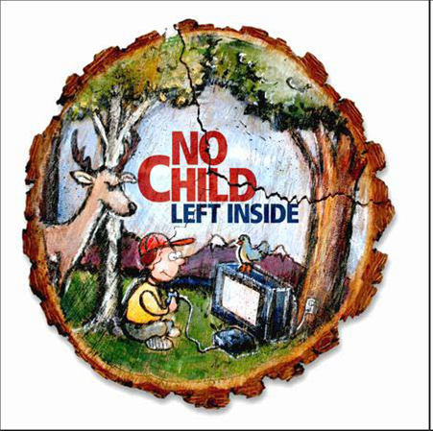

**Outdoor Adventures**

**“Fitness in the Northwest”**

**.5 Physical Education Credit**

**Location: Mt Si High School**

**Instructors: Patrick & Leann Stewart**

**June 17-June 28, 2013**

**General Description**

This course will feature lifelong Northwest fitness activities and students will participate in diverse recreation opportunities in a variety of locations. Students will learn skills and fundamentals that promote a healthy and active lifestyle. The class will provide lifetime skills in outdoor survival as well as outdoor activities. The ultimate goal is to is to develop intrinsically motivated, lifelong fitness habits

**Skills Developed**

Basic knowledge in backpacking, camping, rock climbing, archery, survival skills, orienteering, plant identification, and other outdoor adventures. Students will be in the classroom as well as participate in fitness and outdoor activities.

**Participation**

Students are required to participate in **ALL** Outdoor Education activities and field trips.

**Fitness Requirement**

All students must meet a minimum fitness requirement of being physically able to hike 5 miles, mountain bike 10+ miles and learn introductory rock climbing skills.

**Content/Units**

**Hiking and Survival**

This experience will show students how to use basic tools for surviving in the wilderness; how to understand dangerous situations and avoid them during hiking; analyze the natural environment and determine how to build shelter and stay focused on getting rescued; wilderness first aid, backpacking, trip planning map/compass reading, proper equipment and food sources.

* Archery
* Mountain Biking (Iron Horse/John Wayne Trails)
* Water Safety
* Environmental Ethics
* Orienteering
* Camping
* Basics of mountain climbing (Vertical World/REI)
* Hiking (Rattle Snake Ledge, Little Si, Twin Falls)

**Games**

**Tennis:** Students will develop basic serves and returns and apply these skills to a game situation **Golf**: Students will learn a basic swing, putting, and golf scoring and compete in a 9-hole golf

tournament.

**Ultimate Frisbee**/S**occer:** to promote team play and sportsmanship.

**Lawn Games**: Bocce Ball

**Bowling** (Adventure Bowl)

**Career Component**

A classroom component will include an “outdoor career” research project. Guest speakers will be invited to talk about their various outdoor careers.

**Field Trips/Transportation** Off campus components will include, ***but are not limited to***, Mt Si Golf Course, Vertical World, Cedar Falls Educational Center/Rattlesnake Ledge Hike, Little Si Hike, Twin Falls Hike and Iron Horse/John Wayne Trails. A calendar of event locations, times and costs will be given to students prior to the start of class when all details have been finalized. **Costs** of field trips are not a part of tuition and are additional fees to be paid by the student. This course involves multiple off-campus sites. Transportation is not provided by the District. Parents are responsible for transportation***.***

**Local Resources/Experts** The class will use local experts in the area to share their knowledge.Singletrack Cycling, REI, Pro Ski & Guiding, Cedar Falls Education Center, Park Rangers etc.